**The Report:** "Restaurant Guide App" (Two-Factor Approach);

**Introduction: Business Problem**

**Description of the problem:**

For this data science problem, we will explore on how a "Restaurant Guide App" improve consumer experience by answering the question; Does the two-factor (Rating and Price) approach sufficient to recommend a venue?

**Target audience description:**

To help a group of stakeholders further solve the problem, we will address "Cuisine Connoisseurs, Food Enthusiast and Bloggers" who constantly use restaurant guide app for ease of use.

**Discussion on why our Target audience care about the problem:**

Everything today is accessible by means of smart phones. In the food industry, Cuisine Connoisseurs, Food Enthusiast and Bloggers wants a quick easy way to access venue information. They often want straightforward details without the hassle of too much unnecessary data to influence their decision. Now, how do we improve these experiences? Why should they care about the two-factor approach in this data science problem? - The minimalistic comparison data use, which is combining Rating and Price will give our targeted audience better insight in finding great budget-friendly restaurants in downtown areas.

**Data Section**

**Description of the data:**

The data sets generated in this **Data Section** is to provide insights on our proposed problem. We will focus mainly on Downtown Toronto. First, we will get the Latitude and Longitude value of our approximate defined center, which is the downtown area. We then define a query to search within our desired range and limit for restaurant venues using Foursquare API. Respectively, by making calls to the API, we can get the Restaurant Rating and Price. Using Folium plotting library we can visualize our map of the downtown area.

**Other datasets in combination with the Foursquare location data:**

We will enter coordinates generated from the API for our downtown area to google maps. In doing so, we can pinpoint an address for our approximate defined center and further test venue location accuracy and other information. Also, in combination with Foursquare location data, a 'csv file' that depict Rating and Price will be created from the dataset results.

**Examples of the data:**

* Foursquare Credentials and Version
* The geographical coordinate of Downtown Toronto are 43.6563221, -79.3809161.
* The specific venue category : radius = 500; limit = 10
* JSON file for our dataframe
* Venues_map using folium.Map
* Restaurants IDs using “https://api.foursquare.com/v2/venues…”

**Using Data to solve the problem:**

With the generated Data, we can make selection of existing restaurant in any category. The map visualization will be use to show the distance of the restaurants within the neighborhood. Part of the JSON file is significant in examining our calls to Foursquare API and to transform our dataframe for analysis. Relatively, making calls to Foursquare location data will get our given values to make our comparison. Eventually, this dataset results will help us solve the question if our two-factor (Rating and Price) approach sufficient to recommend a venue. We defined our Foursquare Credentials and Version. Then, using the geopy library, we can get the latitude and longitude values of Downtown Toronto. Here, the geographical coordinate of Downtown Toronto are 43.6563221, -79.3809161.

### The Search for a specific venue:

Imagine our targeted audience (Cuisine Connoisseurs, Food Enthusiast and Bloggers) is in a downtown area using the Restaurant Guide App and wanted to find great budget-friendly restaurants. It is a busy town, a quick comparison of several venues in close proximity would be ideal for they're always on the go. Here, we define a query to search for Restaurant within 500 meters from Downtown Toronto and set our limit to 10. By making a call to Foursquare API we can get the JSON file, assign the relevant part of JSON file to venues then transform the venues into a dataframe.

**The codes are as follows:**

venues = results['response']['venues']

dataframe = json_normalize(venues)

dataframe.head()

**Zoom in for the Output View table above**

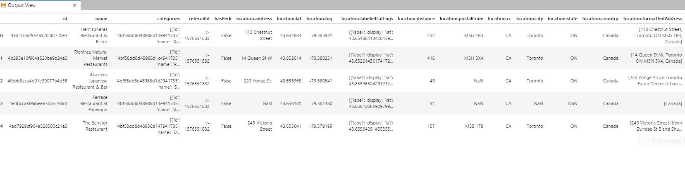

#### Define information of interest and filter dataframe:

Here, we can keep only columns that include venue name, and anything that is associated with location. We can also extract the category of the venue. Filter the category for each row and clean column names by keeping only last term.

**The codes are as follows:**

filtered_columns = ['name', 'categories'] + [col **for** col **in** dataframe.columns **if** col.startswith('location.')] + ['id']

dataframe_filtered = dataframe.loc[:, filtered_columns]

**def** get_category_type(row):

**try**:

categories_list = row['categories']

**except**:

categories_list = row['venue.categories']

**if** len(categories_list) == 0:

**return** **None**

**else**:

**return** categories_list[0]['name']

dataframe_filtered['categories'] = dataframe_filtered.apply(get_category_type, axis=1)

dataframe_filtered.columns = [column.split('.')[-1] **for** column **in** dataframe_filtered.columns]

dataframe_filtered

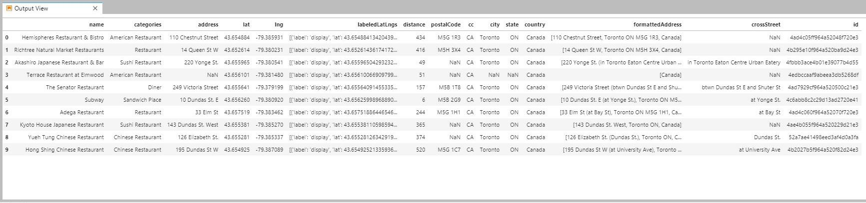

**Zoom in for the Output View table above**

**Filtered dataframe by Restaurant Name:**

0 Hemispheres Restaurant & Bistro

1 Richtree Natural Market Restaurants

2 Akashiro Japanese Restaurant & Bar

3 Terrace Restaurant at Elmwood

4 The Senator Restaurant

5 Subway

6 Adega Restaurant

7 Kyoto House Japanese Restaurant

8 Yueh Tung Chinese Restaurant

9 Hong Shing Chinese Restaurant

### Map of The City’s Downtown Area:

Would it be convenient if we could show our targeted audience the map of their search and visualize how far they are from a prospective venue? Let us locate the approximate center and explore neighboring restaurants.

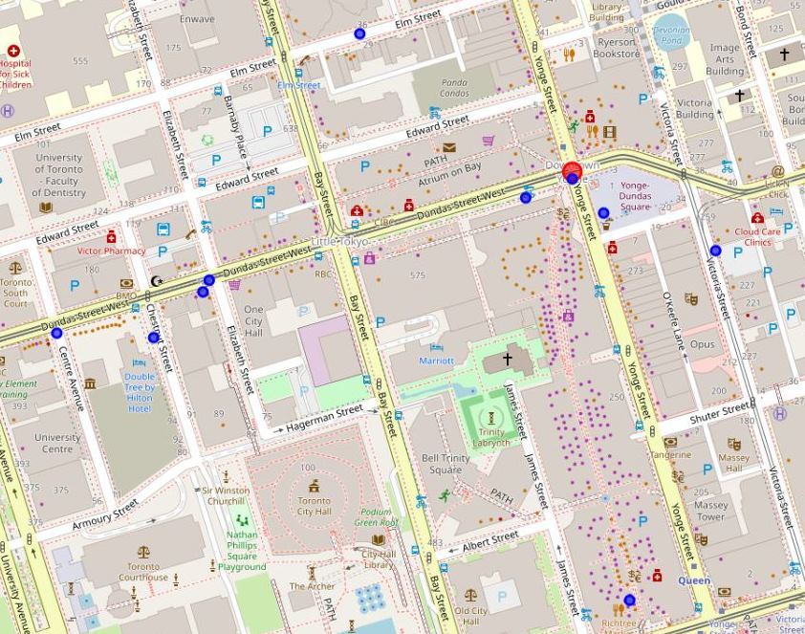

##### **Approximate Defined Center: Google Maps:**

Here, we search for coordinate 43.6563221, -79.3809161, Downtown Toronto. Result shows "The PATH - Yonge-Dundas Square, Toronto, ON, Canada". This is our approximate defined center and represented by a red circle marker from the generated map above. Using the result, we can test venue location accuracy and other information in google maps.

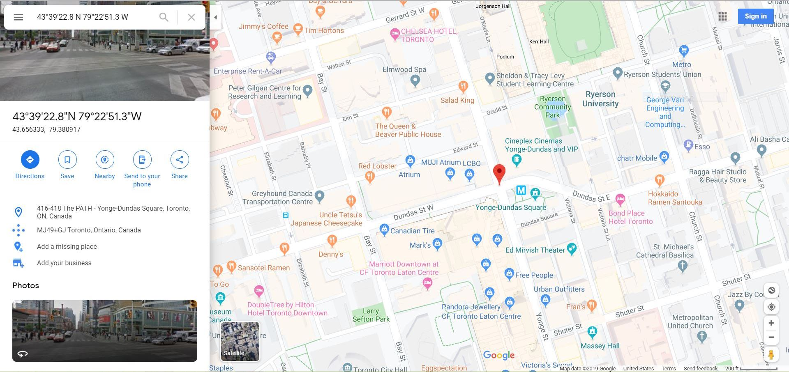

#### Dataframe Clean Up:

Here, we sort the restaurants by distance and clean up the index.

**The codes are as follows:**

sort_by_distance = dataframe_filtered.sort_values('distance')

sort_by_distance

sort_by_distance.style.hide_index()

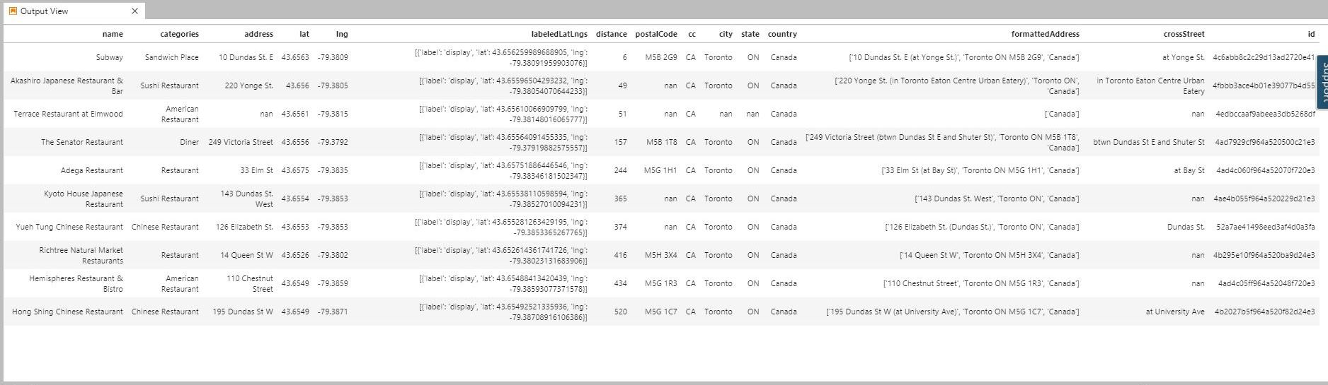

**Zoom in for the Output View table above**

#### Explore Restaurants using their ID:

Here, by making calls to Foursquare API we can get the “Given Values”. We will be using The Senator Restaurant for our pilot call. Then get the Rating, Price, Tier and Currency for others

**The codes are as follows:**

result = requests.get(url).json()

print(result['response']['venue'].keys())

result['response']['venue']

**The Given Values:**

dict_keys(['id', 'name', 'contact', 'location', 'canonicalUrl', 'categories', 'verified', 'stats', 'url', 'price', 'likes', 'dislike', 'ok', 'rating', 'ratingColor', 'ratingSignals', 'allowMenuUrlEdit', 'beenHere', 'specials', 'photos', 'venuePage', 'reasons', 'description', 'storeId', 'page', 'hereNow', 'createdAt', 'tips', 'shortUrl', 'timeZone', 'listed', 'hours', 'popular', 'pageUpdates', 'inbox', 'attributes', 'bestPhoto', 'colors'])

**Template for getting the Rating and Price, the codes are as follows:**

**try**:

print(result['response']['venue']['rating'])

**except**:

print('This venue has not been rated yet.')

**Output:** 7.9

**try**:

print(result['response']['venue']['price'])

**except**:

print('No Details.')

**Output:** {'tier': 2, 'message': 'Moderate', 'currency': '$'}

**Now we leverage the Foursquare location data to the fullest, let's get the Rating, Price, Tier and Currency for other restaurants using our pilot call’s template**

**Outputs:**

5.7

{'tier': 1, 'message': 'Cheap', 'currency': '$'}

5.4

{'tier': 2, 'message': 'Moderate', 'currency': '$'}

This venue has not been rated yet.

{'tier': 2, 'message': 'Moderate', 'currency': '$'}

8.3

No Details.

6.1

{'tier': 2, 'message': 'Moderate', 'currency': '$'}

5.9

{'tier': 2, 'message': 'Moderate', 'currency': '$'}

7.8

{'tier': 1, 'message': 'Cheap', 'currency': '$'}

6.2

{'tier': 2, 'message': 'Moderate', 'currency': '$'}

This venue has not been rated yet.

No Details.

##### **Dataset Results above were extracted to csv format to create a new dataframe. The codes are as follows:**

df_dtres = pd.read_csv('DT_Res_final.csv')

df_dtres

**The New Dataframe:**

|  | **Restaurant** | **Rating** | **Price** |
| --- | --- | --- | --- |
| **0** | Subway | 5.7 | Cheap |
| **1** | Akashiro Japanese Restaurant & Bar | 5.4 | Moderate |
| **2** | Terrace Restaurant at Elmwood | NR | Moderate |
| **3** | The Senator Restaurant | 7.9 | Moderate |
| **4** | The Elm Tree Restaurant | 8.3 | ND |
| **5** | Hendricks Restaurant & Bar | 6.1 | Moderate |
| **6** | Kyoto House Japanese Restaurant | 5.9 | Moderate |
| **7** | Yueh Tung Chinese Restaurant | 7.8 | Cheap |
| **8** | Richtree Natural Market Restaurants | 6.2 | Moderate |
| **9** | Hemispheres Restaurant & Bistro | NR | ND |

We can now sort by category Rating and Price, and “Cheap” as our sub category. Also, we cleaned up the index.

##### **The codes are as follows:**

df_word=df_dtres[df_dtres['Price'].str.contains('Cheap')].reset_index(drop=**True**)

df_word.style.hide_index()

| **Restaurant** | **Rating** | **Price** |
| --- | --- | --- |
| Subway | 5.7 | Cheap |
| Yueh Tung Chinese Restaurant | 7.8 | Cheap |

### Table 1

Repeating the same process, we can sort by sub category “Moderate”.

##### **The codes are as follows:**

df_word=df_dtres[df_dtres['Price'].str.contains('Moderate')].reset_index(drop=**True**)

df_word.style.hide_index()

| **Restaurant** | **Rating** | **Price** |
| --- | --- | --- |
| Akashiro Japanese Restaurant & Bar | 5.4 | Moderate |
| Terrace Restaurant at Elmwood | NR | Moderate |
| The Senator Restaurant | 7.9 | Moderate |
| Hendricks Restaurant & Bar | 6.1 | Moderate |
| Kyoto House Japanese Restaurant | 5.9 | Moderate |
| Richtree Natural Market Restaurants | 6.2 | Moderate |

### Table 2

## Methodology Section

In our Business Problem section, we introduced whether our Restaurant Guide App would be sufficient to recommend a venue focusing only within the Rating and Price. Consequently, from our Data Section, we explained how our datasets were used in solving the business problem. For our **data requirements**, we showed that we need both traditional and non-traditional datasets. Mainly leveraging Foursquare Location Data in conjunction with google maps and 'csv file' created from the dataset results. Relatively from the **collected data**, we have identified all sources and how they were extracted. Thus, providing us with better **understanding and preparation** on how to execute our data science problem. Using data visualization, we have created our **modeling and evaluation** for the Restaurant Guide App (Two-Factor Approach). We have seen the correlations between cleaning up our unstructured and structured datasets to generate our minimalistic results.

## Analysis Section

Stakeholders had to consider the Two-Factor Approach to improve their consumer experience. However, would the gathered datasets enough to deploy this concept? Simple answer is, yes. Let’s **analyze** the "Restaurant Guide App" (Two-Factor Approach); Virtually, Table 1 and 2 shows enough data without overwhelming our targeted audience. Cuisine Connoisseurs, Food Enthusiast and Bloggers, who constantly use restaurant guide app for quick venue information, will appreciate this minimalistic comparison. Stakeholders have to consider the two-factor approach for improvement of consumer experience. Developers then can collaborate and utilize the datasets to come up with ways to show the Tables as part of the app. Sometimes, less can influence significant decisions but not to sacrifice functionality. Here, the Rating and Price is sufficient to recommend a venue. Our tables show us, " Yueh Tung Chinese Restaurant and The Senator Restaurant" as our top picks.  
Based on the new dataframe and with less programming, we see the Rating and Price category influenced our decisions. Here, we show that the categories pulled our preferred restaurants in the downtown areas. Again, without being explicit, we can predict a restaurant with virtually has the most complete values across the board be our top picks. Thus, improve consumer experience. We also have relied on the patterns of our sub categories (Cheap and Moderate) to build our statistical model.

## Results Section

Utilizing all identified sources for our data we can make adjustments to our Two-Factor Approach model upon deployment if needed. Moreover, the predictivenes (virtual comparison) of our model can be fine-tuned using the dataset results. Stakeholders can benefit from its simplicity to refine known testing outcome. Most importantly, with an improved consumer experience in place, it will open opportunities for constructive feedback to re-evaluate efficiency of our Restaurant Guide App. As we can virtually see from the tables, we had analyzed our top picks and answered the main question to the data science problem in our data section.

## Discussion Section

Based on the results, even if we leverage the power of Foursquare Location Data to the fullest, external sources can indeed provide a much adequate visualization. Using basic google map search pinpoint our downtown area and approximately test the distance of our neighborhood restaurants. The spreadsheet manipulation we have created for our new dataframe simplified the dataset results and became grounds for comparison. Realistically provided insights that the Two-Factor Approach (Rating and Price) is sufficient to recommend a venue. As previously mentioned, “Sometimes, less can influence significant decisions but not to sacrifice functionality”. With that in mind, to clean these data is not necessarily mean to disregard parts of dataset result. Every code plays a vital part in providing our targeted audience an improve consumer experience. The minimalistic functional comparison assisted our stakeholders to better understand the impact in developing the Restaurant Guide App. As Data Scientist, it is recommended that all datasets, structured or unstructured should be put in consideration.

## Conclusion Section

Finally, can we deploy the model into practice? Yes, the proprietary "Restaurant Guide App" (Two-Factor Approach) model is predictive. Therefore, can be revaluated, refine adjustments and apply testing to known outcome. Our model is leverage through the power of Foursquare Location Data and external resources. Hence, we can solve real world issues pertaining to our data science problem. We can now be more competitive in today’s market trend by polishing our dataset to improve consumer experience.